**Android Practical BCA**

1. Installation of android studio and printing “hello word”

Sol:

Step1: Download Android Studio

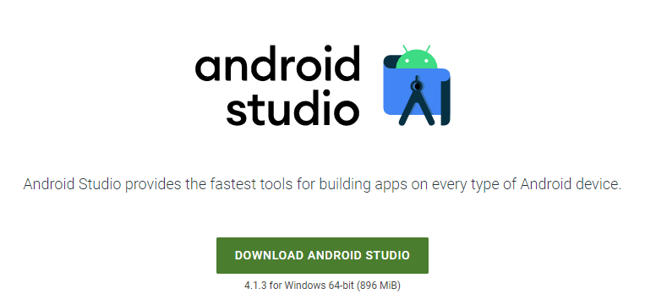

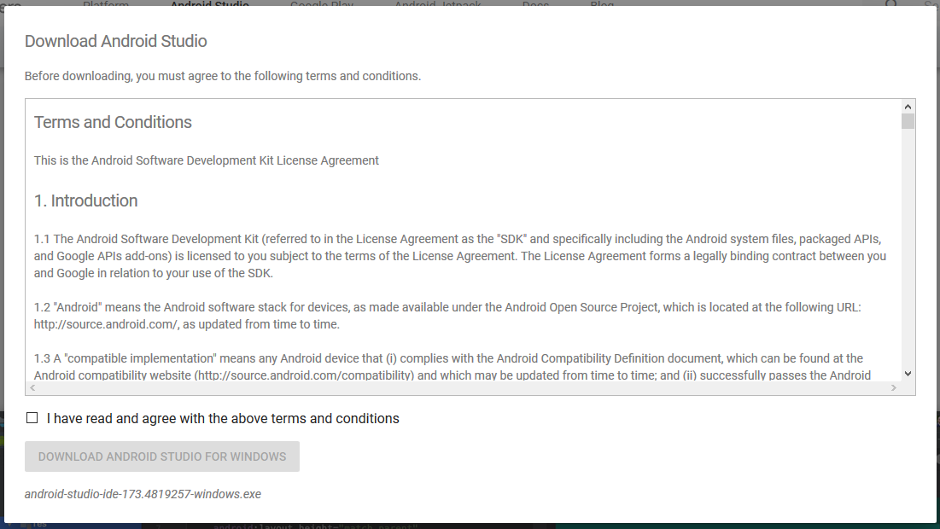

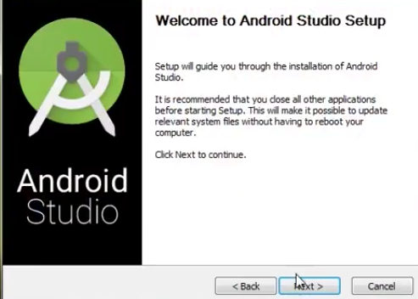

Step-2



Step3

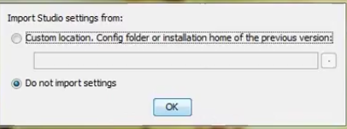

Step4



Step5

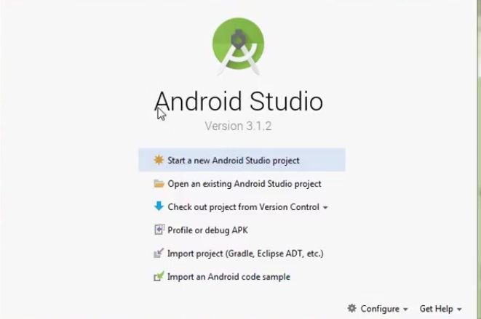

1. Conversion of KG value to Pounds value

Done:

1. Printing results of students

Done:

1. Scientific calculator (which include java operators, >>, <<, &, ~ etc)

Sol:

<?*xml version*="1.0" *encoding*="utf-8"?>  
<androidx.constraintlayout.widget.ConstraintLayout *xmlns:android*="http://schemas.android.com/apk/res/android"  
 *xmlns:app*="http://schemas.android.com/apk/res-auto"  
 *xmlns:tools*="http://schemas.android.com/tools"  
 *android:layout_width*="match_parent"  
 *android:layout_height*="match_parent"  
 *android:visibility*="visible"  
 *tools:context*=".MainActivity">  
  
 <Button  
 *android:id*="@+id/btn4"  
 *android:layout_width*="wrap_content"  
 *android:layout_height*="wrap_content"  
 *android:text*="-"  
 *android:textSize*="34sp"  
 *app:layout_constraintBottom_toBottomOf*="parent"  
 *app:layout_constraintEnd_toEndOf*="parent"  
 *app:layout_constraintHorizontal_bias*="0.037"  
 *app:layout_constraintStart_toStartOf*="parent"  
 *app:layout_constraintTop_toBottomOf*="@+id/btn1"  
 *app:layout_constraintVertical_bias*="0.147" />  
  
 <EditText  
 *android:id*="@+id/n1"  
 *android:layout_width*="wrap_content"  
 *android:layout_height*="wrap_content"  
 *android:ems*="10"  
 *android:hint*="num1"  
 *android:inputType*="numberDecimal"  
 *app:layout_constraintBottom_toBottomOf*="parent"  
 *app:layout_constraintEnd_toEndOf*="parent"  
 *app:layout_constraintHorizontal_bias*="0.497"  
 *app:layout_constraintStart_toStartOf*="parent"  
 *app:layout_constraintTop_toTopOf*="parent"  
 *app:layout_constraintVertical_bias*="0.176" />  
  
 <EditText  
 *android:id*="@+id/n2"  
 *android:layout_width*="wrap_content"  
 *android:layout_height*="wrap_content"  
 *android:ems*="10"  
 *android:hint*="num2"  
 *android:inputType*="numberDecimal"  
 *app:layout_constraintBottom_toBottomOf*="parent"  
 *app:layout_constraintEnd_toEndOf*="parent"  
 *app:layout_constraintHorizontal_bias*="0.497"  
 *app:layout_constraintStart_toStartOf*="parent"  
 *app:layout_constraintTop_toBottomOf*="@+id/n1"  
 *app:layout_constraintVertical_bias*="0.076" />  
  
 <Button  
 *android:id*="@+id/btn1"  
 *android:layout_width*="wrap_content"  
 *android:layout_height*="wrap_content"  
 *android:text*="+"  
 *android:textSize*="34sp"  
 *app:layout_constraintBottom_toBottomOf*="parent"  
 *app:layout_constraintEnd_toEndOf*="parent"  
 *app:layout_constraintHorizontal_bias*="0.05"  
 *app:layout_constraintStart_toStartOf*="parent"  
 *app:layout_constraintTop_toBottomOf*="@+id/n2"  
 *app:layout_constraintVertical_bias*="0.353" />  
  
 <Button  
 *android:id*="@+id/btn2"  
 *android:layout_width*="wrap_content"  
 *android:layout_height*="wrap_content"  
 *android:text*="*"  
 *android:textSize*="34sp"  
 *app:layout_constraintBottom_toBottomOf*="parent"  
 *app:layout_constraintEnd_toEndOf*="parent"  
 *app:layout_constraintHorizontal_bias*="0.187"  
 *app:layout_constraintStart_toEndOf*="@+id/btn1"  
 *app:layout_constraintTop_toBottomOf*="@+id/n2"  
 *app:layout_constraintVertical_bias*="0.36" />  
  
 <TextView  
 *android:id*="@+id/tv1"  
 *android:layout_width*="wrap_content"  
 *android:layout_height*="wrap_content"  
 *android:textSize*="60sp"  
 *android:visibility*="visible"  
 *app:layout_constraintBottom_toTopOf*="@+id/btn2"  
 *app:layout_constraintEnd_toEndOf*="parent"  
 *app:layout_constraintStart_toStartOf*="parent"  
 *app:layout_constraintTop_toBottomOf*="@+id/n2" />  
  
 <Button  
 *android:id*="@+id/btn3"  
 *android:layout_width*="82dp"  
 *android:layout_height*="58dp"  
 *android:text*="/"  
 *android:textSize*="20sp"  
 *app:layout_constraintBottom_toBottomOf*="parent"  
 *app:layout_constraintEnd_toEndOf*="parent"  
 *app:layout_constraintHorizontal_bias*="0.505"  
 *app:layout_constraintStart_toEndOf*="@+id/btn2"  
 *app:layout_constraintTop_toBottomOf*="@+id/tv1"  
 *app:layout_constraintVertical_bias*="0.114" />  
  
 <Button  
 *android:id*="@+id/btn5"  
 *android:layout_width*="81dp"  
 *android:layout_height*="63dp"  
 *android:text*=">>"  
 *android:textSize*="34sp"  
 *app:layout_constraintBottom_toBottomOf*="parent"  
 *app:layout_constraintEnd_toEndOf*="parent"  
 *app:layout_constraintHorizontal_bias*="0.195"  
 *app:layout_constraintStart_toEndOf*="@+id/btn4"  
 *app:layout_constraintTop_toBottomOf*="@+id/btn2"  
 *app:layout_constraintVertical_bias*="0.142" />  
</androidx.constraintlayout.widget.ConstraintLayout>

*package* com.example.scientificcalculator;  
  
*import* androidx.appcompat.app.AppCompatActivity;  
  
*import* android.os.Bundle;  
*import* android.view.View;  
*import* android.widget.Button;  
*import* android.widget.EditText;  
*import* android.widget.TextView;  
  
*public class* MainActivity *extends* AppCompatActivity {  
*private* Button btn1;  
*private* Button btn2;  
*private* EditText n1;  
*private* EditText n2;  
*private* TextView tv1;  
 @Override  
 *protected void* onCreate(Bundle savedInstanceState) {  
 *super*.onCreate(savedInstanceState);  
 setContentView(R.layout.***activity_main***);  
 btn1=findViewById(R.id.***btn1***);  
 btn2=findViewById(R.id.***btn2***);  
 n1=findViewById(R.id.***n1***);  
 n2=findViewById(R.id.***n2***);  
 tv1=findViewById(R.id.***tv1***);  
 btn1.setOnClickListener(*new* View.OnClickListener() {  
 @Override  
 *public void* onClick(View view) {  
  
 *int* a=Integer.*parseInt*(n1.getText().toString());  
 *int* b=Integer.*parseInt*(n2.getText().toString());  
 *int* c=a+b;  
 String d=Integer.*toString*(c);  
 tv1.setText(d);  
 }  
 });  
 btn2.setOnClickListener(*new* View.OnClickListener() {  
 @Override  
 *public void* onClick(View view) {  
 *int* a=Integer.*parseInt*(n1.getText().toString());  
 *int* b=Integer.*parseInt*(n2.getText().toString());  
 *int* c=a*b;  
 String d=Integer.*toString*(c);  
 tv1.setText(d);  
 }  
 });  
 }  
}

output:

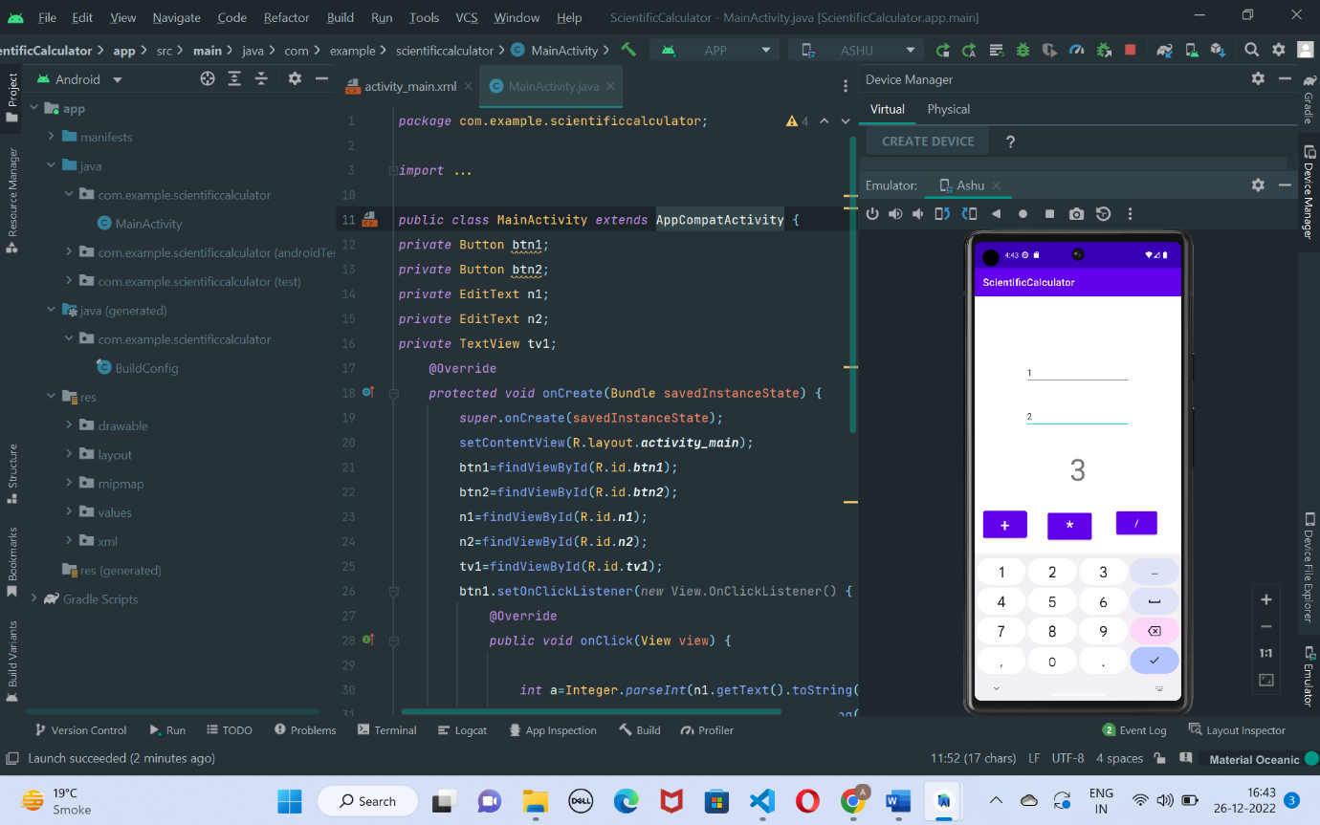

1. Changing icon image

1. Showing toast message on screen changing different layouts
2. Demonstration of button, edit view, text view and setting click listeners
3. Playing media player
4. <?*xml version*="1.0" *encoding*="utf-8"?>  
   <androidx.appcompat.widget.LinearLayoutCompat *xmlns:android*="http://schemas.android.com/apk/res/android"  
    *xmlns:app*="http://schemas.android.com/apk/res-auto"  
    *xmlns:tools*="http://schemas.android.com/tools"  
    *android:layout_width*="match_parent"  
    *android:layout_height*="match_parent"  
    *tools:context*=".MainActivity"  
    *android:orientation*="vertical">  
     
    <Button  
    *android:id*="@+id/play"  
    *android:layout_width*="match_parent"  
    *android:layout_height*="wrap_content"  
    *android:text*="PLAY"  
    *android:onClick*="videoPlay"/>  
     
    <VideoView  
    *android:id*="@+id/videoView"  
    *android:layout_width*="match_parent"  
    *android:layout_height*="match_parent" />  
   </androidx.appcompat.widget.LinearLayoutCompat>
5. Setting media controllers
6. <?*xml version*="1.0" *encoding*="utf-8"?>  
   <androidx.appcompat.widget.LinearLayoutCompat *xmlns:android*="http://schemas.android.com/apk/res/android"  
    *xmlns:app*="http://schemas.android.com/apk/res-auto"  
    *xmlns:tools*="http://schemas.android.com/tools"  
    *android:layout_width*="match_parent"  
    *android:layout_height*="match_parent"  
    *tools:context*=".MainActivity"  
    *android:orientation*="vertical">  
     
    <Button  
    *android:id*="@+id/play"  
    *android:layout_width*="match_parent"  
    *android:layout_height*="wrap_content"  
    *android:text*="PLAY"  
    *android:onClick*="videoPlay"/>  
     
    <VideoView  
    *android:id*="@+id/videoView"  
    *android:layout_width*="match_parent"  
    *android:layout_height*="match_parent" />  
   </androidx.appcompat.widget.LinearLayoutCompat>

*package* com.example.video;  
  
*import* androidx.appcompat.app.AppCompatActivity;  
  
*import* android.net.Uri;  
*import* android.os.Bundle;  
*import* android.view.View;  
*import* android.widget.Button;  
*import* android.widget.MediaController;  
*import* android.widget.VideoView;  
  
*public class* MainActivity *extends* AppCompatActivity {  
 *private* Button play;  
 *private* VideoView videoView;  
 *private* MediaController mdc;  
  
 @Override  
 *protected void* onCreate(Bundle savedInstanceState) {  
 *super*.onCreate(savedInstanceState);  
 setContentView(R.layout.***activity_main***);  
 play=findViewById(R.id.***play***);  
 videoView=findViewById(R.id.***videoView***);  
 mdc=*new* MediaController(*this*);  
 }  
 *public void* videoPlay(View view){  
 String path="android.resource://com.example.video/"+R.raw.***vdo***;  
 Uri url= Uri.*parse*(path);  
 videoView.setVideoURI(url);  
 videoView.setMediaController(mdc);  
 mdc.setAnchorView(videoView);  
 videoView.start();  
  
 }  
}

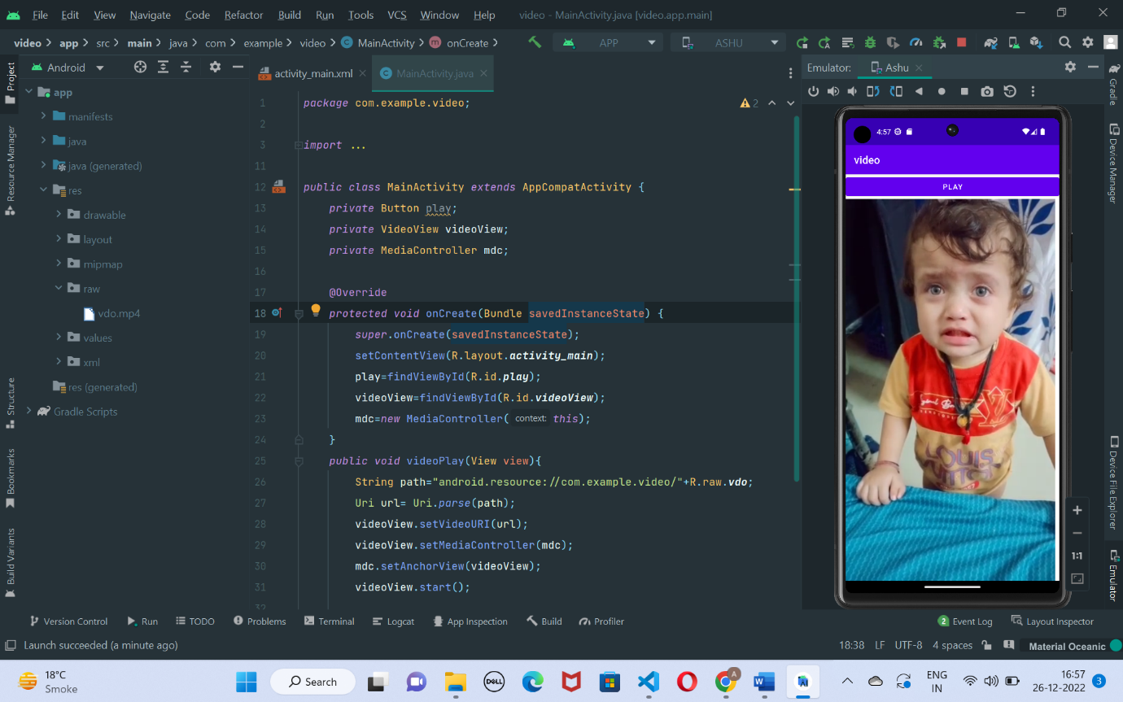

1. Demonstration of intent by opening new activities
2. <?*xml version*="1.0" *encoding*="utf-8"?>  
   <androidx.constraintlayout.widget.ConstraintLayout *xmlns:android*="http://schemas.android.com/apk/res/android"  
    *xmlns:app*="http://schemas.android.com/apk/res-auto"  
    *xmlns:tools*="http://schemas.android.com/tools"  
    *android:layout_width*="match_parent"  
    *android:layout_height*="match_parent"  
    *tools:context*=".MainActivity">  
     
    <EditText  
    *android:id*="@+id/et1"  
    *android:layout_width*="wrap_content"  
    *android:layout_height*="wrap_content"  
    *android:ems*="10"  
    *android:hint*="Enter data"  
    *android:inputType*="textPersonName"  
    *app:layout_constraintBottom_toBottomOf*="parent"  
    *app:layout_constraintEnd_toEndOf*="parent"  
    *app:layout_constraintHorizontal_bias*="0.497"  
    *app:layout_constraintStart_toStartOf*="parent"  
    *app:layout_constraintTop_toTopOf*="parent"  
    *app:layout_constraintVertical_bias*="0.393" />  
     
    <Button  
    *android:id*="@+id/btn1"  
    *android:layout_width*="wrap_content"  
    *android:layout_height*="wrap_content"  
    *android:onClick*="newScreen"  
    *android:text*="Send Name"  
    *app:layout_constraintBottom_toBottomOf*="parent"  
    *app:layout_constraintEnd_toEndOf*="parent"  
    *app:layout_constraintHorizontal_bias*="0.498"  
    *app:layout_constraintStart_toStartOf*="parent"  
    *app:layout_constraintTop_toBottomOf*="@+id/et1"  
    *app:layout_constraintVertical_bias*="0.293" />  
     
   </androidx.constraintlayout.widget.ConstraintLayout>

*package* com.example.multi2;  
  
*import* androidx.appcompat.app.AppCompatActivity;  
  
*import* android.content.Intent;  
*import* android.os.Bundle;  
*import* android.view.View;  
*import* android.widget.Button;  
*import* android.widget.EditText;  
*import* android.widget.Toast;  
  
*public class* MainActivity *extends* AppCompatActivity {  
 *private* Button btn1;  
 *private* EditText et1;  
 *public static final* String ***EXTRA***="RAM";  
 @Override  
 *protected void* onCreate(Bundle savedInstanceState) {  
 *super*.onCreate(savedInstanceState);  
 setContentView(R.layout.***activity_main***);  
 }  
 *public void* newScreen(View view) {  
 btn1=findViewById(R.id.***btn1***);  
 et1=findViewById(R.id.***et1***);  
 String txt=et1.getText().toString();  
 Intent intent=*new* Intent(*this*,MainActivity2.*class*);  
 intent.putExtra(***EXTRA***,txt);  
 startActivity(intent);  
 }  
}

<?*xml version*="1.0" *encoding*="utf-8"?>  
<androidx.constraintlayout.widget.ConstraintLayout *xmlns:android*="http://schemas.android.com/apk/res/android"  
 *xmlns:app*="http://schemas.android.com/apk/res-auto"  
 *xmlns:tools*="http://schemas.android.com/tools"  
 *style*="@style/Theme.Multi2"  
 *android:layout_width*="match_parent"  
 *android:layout_height*="match_parent"  
 *tools:context*=".MainActivity2">  
  
 <TextView  
 *android:id*="@+id/textView"  
 *android:layout_width*="wrap_content"  
 *android:layout_height*="wrap_content"  
 *android:textAppearance*="@style/TextAppearance.AppCompat.Medium"  
 *android:textColor*="#E91E63"  
 *android:textColorHighlight*="#CDDC39"  
 *android:textSize*="24sp"  
 *android:textStyle*="bold|italic"  
 *app:layout_constraintBottom_toBottomOf*="parent"  
 *app:layout_constraintEnd_toEndOf*="parent"  
 *app:layout_constraintStart_toStartOf*="parent"  
 *app:layout_constraintTop_toTopOf*="parent" />  
</androidx.constraintlayout.widget.ConstraintLayout>

*package* com.example.multi2;  
  
*import* androidx.appcompat.app.AppCompatActivity;  
  
*import* android.content.Intent;  
*import* android.os.Bundle;  
*import* android.widget.TextView;  
  
*public class* MainActivity2 *extends* AppCompatActivity {  
 *private* TextView txt;  
 @Override  
 *protected void* onCreate(Bundle savedInstanceState) {  
 *super*.onCreate(savedInstanceState);  
 setContentView(R.layout.***activity_main2***);  
 txt=findViewById(R.id.***textView***);  
 String cont=txt.getText().toString();  
 Intent I=getIntent();  
 String msg=I.getStringExtra(MainActivity.***EXTRA***);  
  
 txt.setText("Hi "+ msg + " welcome to new page");  
 getIntent();  
  
 }  
}

output

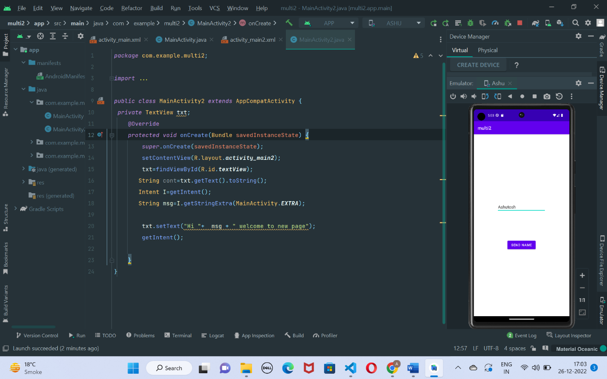

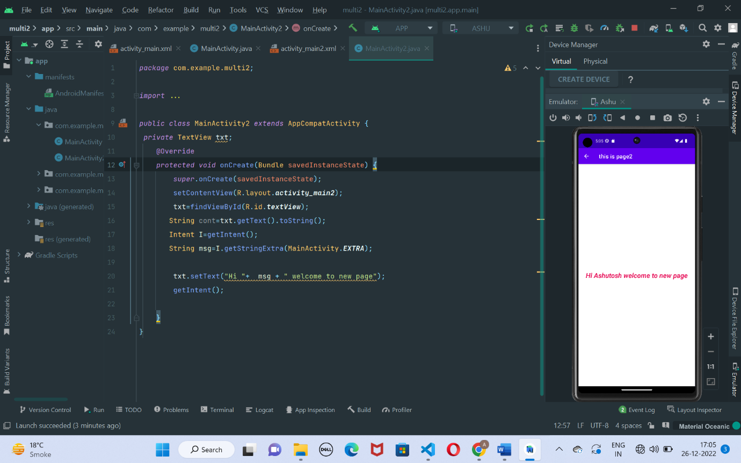

1. Setting image in image view
2. Designing simple quiz application
3. <?*xml version*="1.0" *encoding*="utf-8"?>  
   <androidx.constraintlayout.widget.ConstraintLayout *xmlns:android*="http://schemas.android.com/apk/res/android"  
    *xmlns:app*="http://schemas.android.com/apk/res-auto"  
    *xmlns:tools*="http://schemas.android.com/tools"  
    *android:layout_width*="match_parent"  
    *android:layout_height*="match_parent"  
    *tools:context*=".MainActivity">  
     
    <ImageView  
    *android:id*="@+id/imageView"  
    *android:layout_width*="278dp"  
    *android:layout_height*="154dp"  
    *app:layout_constraintBottom_toBottomOf*="parent"  
    *app:layout_constraintEnd_toEndOf*="parent"  
    *app:layout_constraintHorizontal_bias*="0.442"  
    *app:layout_constraintStart_toStartOf*="parent"  
    *app:layout_constraintTop_toTopOf*="parent"  
    *app:layout_constraintVertical_bias*="0.113"  
    *app:srcCompat*="@drawable/img1" />  
     
    <TextView  
    *android:id*="@+id/textView"  
    *android:layout_width*="wrap_content"  
    *android:layout_height*="wrap_content"  
    *android:text*="Welcome to java Quiz"  
    *android:textColor*="#E91E63"  
    *android:textSize*="34sp"  
    *android:textStyle*="bold|italic"  
    *app:layout_constraintBottom_toBottomOf*="parent"  
    *app:layout_constraintEnd_toEndOf*="parent"  
    *app:layout_constraintHorizontal_bias*="0.458"  
    *app:layout_constraintStart_toStartOf*="parent"  
    *app:layout_constraintTop_toBottomOf*="@+id/imageView"  
    *app:layout_constraintVertical_bias*="0.121" />  
     
    <TextView  
    *android:id*="@+id/TV2"  
    *android:layout_width*="wrap_content"  
    *android:layout_height*="wrap_content"  
    *android:text*="TextView"  
    *android:textColor*="#673AB7"  
    *android:textSize*="34sp"  
    *app:layout_constraintBottom_toBottomOf*="parent"  
    *app:layout_constraintEnd_toEndOf*="parent"  
    *app:layout_constraintHorizontal_bias*="0.443"  
    *app:layout_constraintStart_toStartOf*="parent"  
    *app:layout_constraintTop_toBottomOf*="@+id/textView"  
    *app:layout_constraintVertical_bias*="0.128" />  
     
    <Button  
    *android:id*="@+id/YES"  
    *android:layout_width*="105dp"  
    *android:layout_height*="75dp"  
    *android:layout_marginBottom*="176dp"  
    *android:text*="YES"  
    *android:textSize*="20sp"  
    *app:layout_constraintBottom_toBottomOf*="parent"  
    *app:layout_constraintEnd_toStartOf*="@+id/NO"  
    *app:layout_constraintHorizontal_bias*="0.415"  
    *app:layout_constraintStart_toStartOf*="parent"  
    *app:layout_constraintTop_toBottomOf*="@+id/textView2"  
    *app:layout_constraintVertical_bias*="0.399" />  
     
    <Button  
    *android:id*="@+id/NO"  
    *android:layout_width*="107dp"  
    *android:layout_height*="82dp"  
    *android:layout_marginBottom*="176dp"  
    *android:text*="NO"  
    *android:textSize*="20sp"  
    *app:layout_constraintBottom_toBottomOf*="parent"  
    *app:layout_constraintEnd_toEndOf*="parent"  
    *app:layout_constraintHorizontal_bias*="0.756"  
    *app:layout_constraintStart_toStartOf*="parent"  
    *app:layout_constraintTop_toBottomOf*="@+id/textView2"  
    *app:layout_constraintVertical_bias*="0.411" />  
   </androidx.constraintlayout.widget.ConstraintLayout>

*package* com.example.quizapp;  
  
*import* androidx.appcompat.app.AppCompatActivity;  
  
*import* android.os.Bundle;  
*import* android.view.View;  
*import* android.widget.Button;  
*import* android.widget.TextView;  
*import* android.widget.Toast;  
  
*public class* MainActivity *extends* AppCompatActivity {  
*private* Button YES;  
*private* Button NO;  
*private* TextView TV2;  
 String[] quest={"is java oops ?","java owned by google?","java support inheritance?"," Quiz ended"};  
 *boolean*[] ans={*true*,*false*,*true*};  
 *int* index=0;  
 *int* score=0;  
 @Override  
 *protected void* onCreate(Bundle savedInstanceState) {  
 *super*.onCreate(savedInstanceState);  
 setContentView(R.layout.***activity_main***);  
 YES=findViewById(R.id.***YES***);  
 NO=findViewById(R.id.***NO***);  
 TV2=findViewById(R.id.***TV2***);  
 TV2.setText(quest[index]);  
  
 YES.setOnClickListener(*new* View.OnClickListener() {  
 @Override  
 *public void* onClick(View view) {  
 *// Toast.makeText(MainActivity.this, "yes clicked", Toast.LENGTH_SHORT).show();  
 if*(index<quest.length-1) {  
 *if* (ans[index] == *true*)  
 score++;  
 TV2.setText(quest[++index]);  
 }*else* {  
 TV2.setText("your score is :"+ score+"/"+(quest.length-1));  
 }  
 }  
 });  
 NO.setOnClickListener(*new* View.OnClickListener() {  
 @Override  
 *public void* onClick(View view) {  
 *//Toast.makeText(MainActivity.this, "NO clicked", Toast.LENGTH_SHORT).show();  
 if* (index<quest.length-1) {  
 *if* (ans[index] == *false*)  
 score++;  
 TV2.setText(quest[++index]);  
 }  
 *else*{  
 TV2.setText("your score is :"+ score+"/"+(quest.length-1));  
 }  
  
  
  
 }  
 });  
  
  
 }  
  
}

Output

